Online Marketing
A Project Report Submitted
for

Information Technology
By
Payal bahtt

Under the guidance of
Mr. Praveen Kumar Joshi

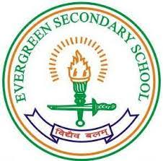

EVER GREEN SENIOR SECONDARY SCHOOL
(GOVERNED BY EDUCATIONAL WELFARE SOCIETY)
TULARAMPUR - 223139, DISTRICT-NAINITAL
UTTARAKHAND, INDIA

OCTOBER, 2021

CERTIFICATE

This is to certify that the project entitled “online marketing ” being submitted to Evergeen Senior Secondary School, Haldwani for the project work of INFORMATION TECHNOLOGY is a record of the work carried by payal bhatt under my guidance and supervision.

Date: 12october ,2021 Supervisor
MR. PRAVEENJOSHI
TGT Computer
Ever Green Sr. Sec. School, Haldwani
Forwarded By:
MR. M.S. PARWAL
Principal
Ever Green Sr. Sec. School, Haldwani

ABSTRACT
Online Marketing is the web based channels to spread brands, products to service to the potential customers.

ACKNOWLEDGEMENTS
I would like to express my most sincere heartfelt gratitude and respect to my supervisor MR. PRAVEEN JOSHI, for suggesting the topic for my project work and for his excellent guidance, valuable suggestions and endless support throughout for preparing the report. I am greatly indebted to him for his constructive suggestions and criticism from time to time during the course of progress of my work.
I would like to express my gratitude and sincere thanks to Mr. M.S. Parwal, Principal of School, and entire faculty who has imparted considerable knowledge to me.
Finally, I express my deepest gratitude to my parents for their continuous encouragement, understanding and support.

(Payal bhatt )

TABLE OF CONTENTS

Chapter | Topic | Page No.
 | CERTIFICATE
 | ACKNOWLEDGEMENT
 | LIST OF FIGURES
 | ABSTRACT
1. | INTRODUCTION
1.1 | Online Marketing | 1-2
1.2
1.2.1
1.2.2
1.2.3
2.
3.
4.
4.1
4.2
4.3
4.4
5.
6. | SUMMARY AND FUTURE WORK | 16
 | REFERENCES | 17-18

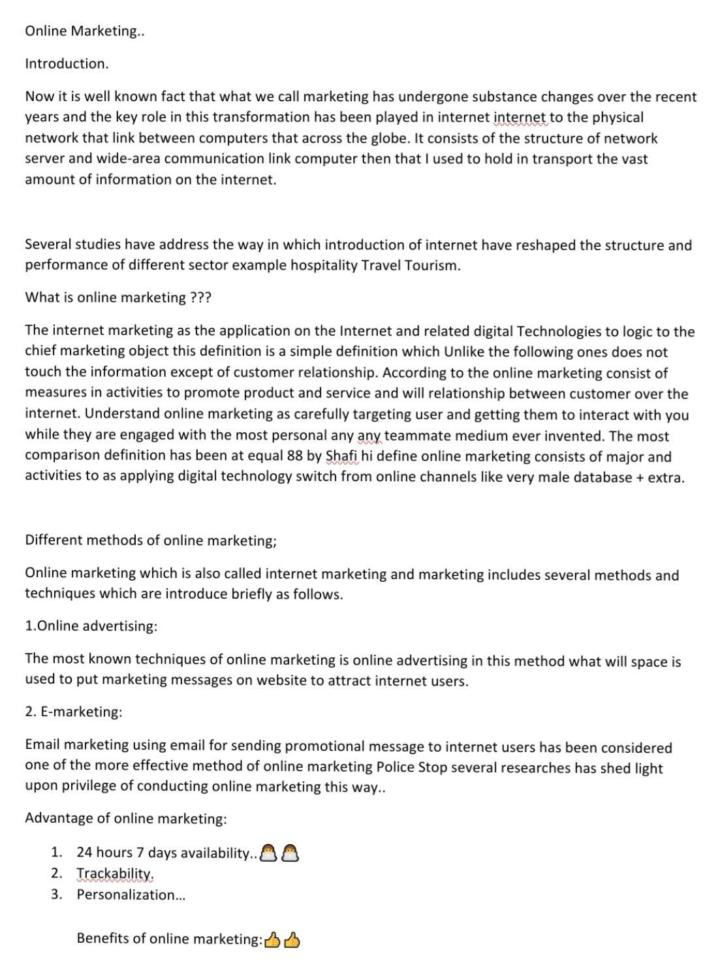

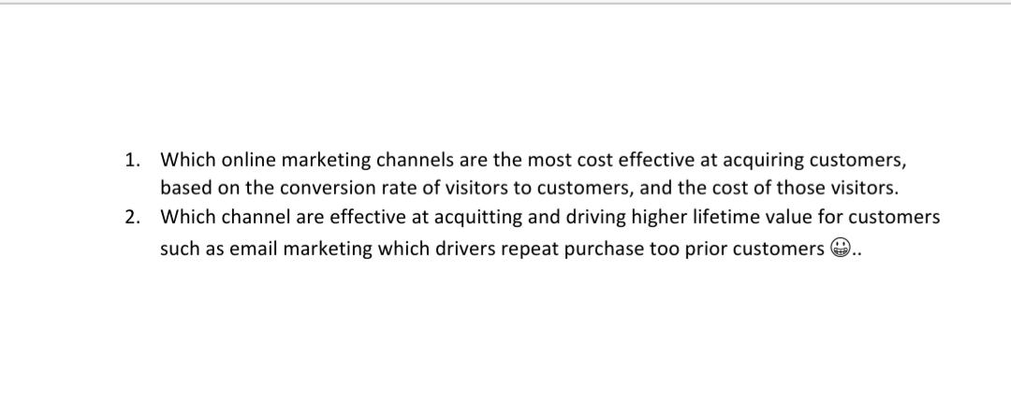
FUTURE WORK OF ONLINE MARKETING.

In future the online marketing are in in Trend. Online marketing famous because nobody like to go outside n all . In online marketing dilevery boy come at home and give the courier to in future online marketing are on trend …

